15th September, 2017

A01630510

Victor Manuel García Rosales

Name of the course: TC2007

Métodos Cuantitativos y Simulación

The design of experiments DOE constructed

Brief description of the experiment, how was physically executed.

* The experiment was executed by teams conformed of 2 people
* First of all, we only cut and fold every single paper that we had. The results were several paper aircrafts with different features.
* We dropped every single aircraft from the 3rd floor of a building.
* Then we measured 3 different times, the total time that lasts the aircraft to fall down from the 3rd floor.
* Then we only get the average from that 3 different measurements.
* Our time is denominated as our dependent variable, so the independent variables are our features over the aircraft.
* The linear regression model is developed in the next following lines, with python & R.
* The results that we obtained were the coefficients and the coefficient determinant, as well as our residuals and our predicted values.
* Finally, we plot every single comparison between the average time & residuals, average time & predicted values, every feature & Time predicted.

Compute the linear regression model (y=B0+B1x1+B2x2.....) using both:

**R Code**

setwd("/Users/victormanuel/Downloads") #Set the directory

df <- read.csv("data-set.csv", header = FALSE)

names(df) <- c('Clip','Body', 'Wing', 'Papertype','Fly1','Fly2', 'Fly3', 'FlyAvg')

model <- lm(FlyAvg ~ Clip + Body + Wing + Papertype, df)

model #Define the model & then execute it

Call:

lm(formula = FlyAvg ~ Clip + Body + Wing + Papertype, data = df)

Coefficients:

(Intercept) Clip Body Wing Papertype

6.7604 0.3708 0.6542 1.5792 -3.7625

summary(model)

Call:

lm(formula = FlyAvg ~ Clip + Body + Wing + Papertype, data = df)

Residuals:

Min 1Q Median 3Q Max

-0.93125 -0.67708 -0.05625 0.33333 2.10208

Coefficients:

Estimate Std. Error t value Pr(>|t|)

(Intercept) 6.7604 0.5099 13.259 4.14e-08 ***

Clip 0.3708 0.4560 0.813 0.43337

Body 0.6542 0.4560 1.434 0.17926

Wing 1.5792 0.4560 3.463 0.00531 **

Papertype -3.7625 0.4560 -8.250 4.87e-06 ***

---

Signif. codes: 0 '***' 0.001 '**' 0.01 '*' 0.05 '.' 0.1 ' ' 1

Residual standard error: 0.9121 on 11 degrees of freedom

Multiple R-squared: 0.8827, Adjusted R-squared: 0.84

F-statistic: 20.69 on 4 and 11 DF, p-value: 4.453e-05

df$predicted <- predict(model) #Compare the predicted time vs the residuals & plot them

df$residuals <- residuals(model)

install.packages("dplyr")

library(dplyr)

df

plot(df$FlyAvg, df$residuals,ylab="Residuals", xlab="FlyAvg", pch = 16, cex = 1.3, col = "blue", main = "Residuals vs Avg Time")

abline(0,0, col = "red")

plot(df$predicted, df$residuals,ylab="Residuals", xlab="Predicted(Y)", pch = 16, cex = 1.3, col = "blue", main = "Residuals vs Predicted")

abline(0,0, col = "red")

#Get an histogram of the residuals distribution & then plot it

r <- df$residuals

h <- hist(r, breaks = 10, density = 10, col = "lightgray", xlab = "Residuals", main = "Histogram of residuals")

xfit <- seq(min(r), max(r), length = 40)

yfit <- dnorm(xfit, mean = mean(r), sd = sd(r))

yfit <- yfit * diff(h$mids[1:2]) * length(r)

lines(xfit, yfit, col = "black", lwd = 2)

residuals.stdres = rstandard(model)

qqnorm(residuals.stdres, ylab = "Standardized Residuals", xlab = "Normal Scores", pch = 16, cex = 1.3, col="blue", main = "" )

qqline(residuals.stdres)

**◦Python**

**import** matplotlib.pyplot **as** plt  
**import** numpy **as** np  
**import** csv  
**from** sklearn **import** linear_model  
*# Load dataset, no header*filename = **'data-set.csv'**raw_data = open(filename, **'rt'**)  
data = np.loadtxt(raw_data, delimiter=**","**)  
*# x y*matrix_X = data[:,0:4]  
matrix_Y= data[:,7]  
*# Create MuLTIPLE linear regression object*modelM = linear_model.LinearRegression()  
modelM.fit(matrix_X,matrix_Y)  
*# The coefficients***print**(**'Coefficients:'**)  
**print**(**'B0: \n'**, modelM.intercept_)  
**print**(**'B1: \n'**, modelM.coef_[0])  
**print**(**'B2: \n'**, modelM.coef_[1])  
**print**(**'B3: \n'**, modelM.coef_[2])  
**print**(**'B4: \n'**, modelM.coef_[3])  
*# R^2***print**(**'R^2: \n'**, modelM.score(matrix_X, matrix_Y))  
*# Different plots of every feature vs the predicted time*  
plt.plot(data[:,0],matrix_Y, **'o'**, label = **' Time predicted vs Clip'**)  
plt.plot(data[:, 0], modelM.intercept_ + modelM.coef_[0]*data[:,0], **'r'**, label = **'fitted line'**)  
plt.xlabel(**'Clip'**)  
plt.ylabel(**'Time'**)  
plt.legend()  
plt.show()  
plt.plot(data[:,1],matrix_Y, **'o'**, label = **' Time predicted vs Body'**)  
plt.plot(data[:, 1], modelM.intercept_ + modelM.coef_[1]*data[:,1], **'r'**, label = **'fitted line'**)  
plt.xlabel(**'Body'**)  
plt.ylabel(**'Time'**)  
plt.legend()  
plt.show()  
plt.plot(data[:,2],matrix_Y, **'o'**, label = **' Time predicted vs Wing'**)  
plt.plot(data[:, 2], modelM.intercept_ + modelM.coef_[2]*data[:,2], **'r'**, label = **'fitted line'**)  
plt.xlabel(**'Wing'**)  
plt.ylabel(**'Time'**)  
plt.legend()  
plt.show()  
plt.plot(data[:,3],matrix_Y, **'o'**, label = **' Time predicted vs Paper Type'**)  
plt.plot(data[:, 3], modelM.intercept_ + modelM.coef_[3]*data[:,3], **'r'**, label = **'fitted line'**)  
plt.xlabel(**'Paper Type'**)  
plt.ylabel(**'Time'**)  
plt.legend()  
plt.show()

• In a Layout (2, 2) plot the “Flight time” vs every independent variable (i.e., x) 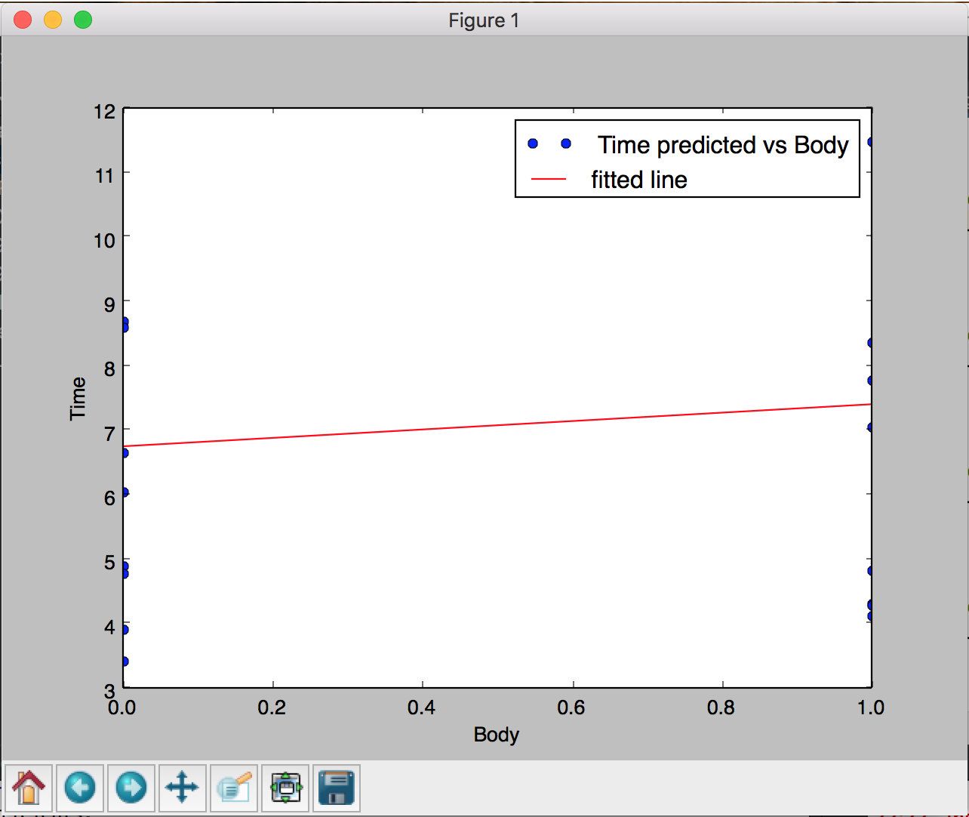

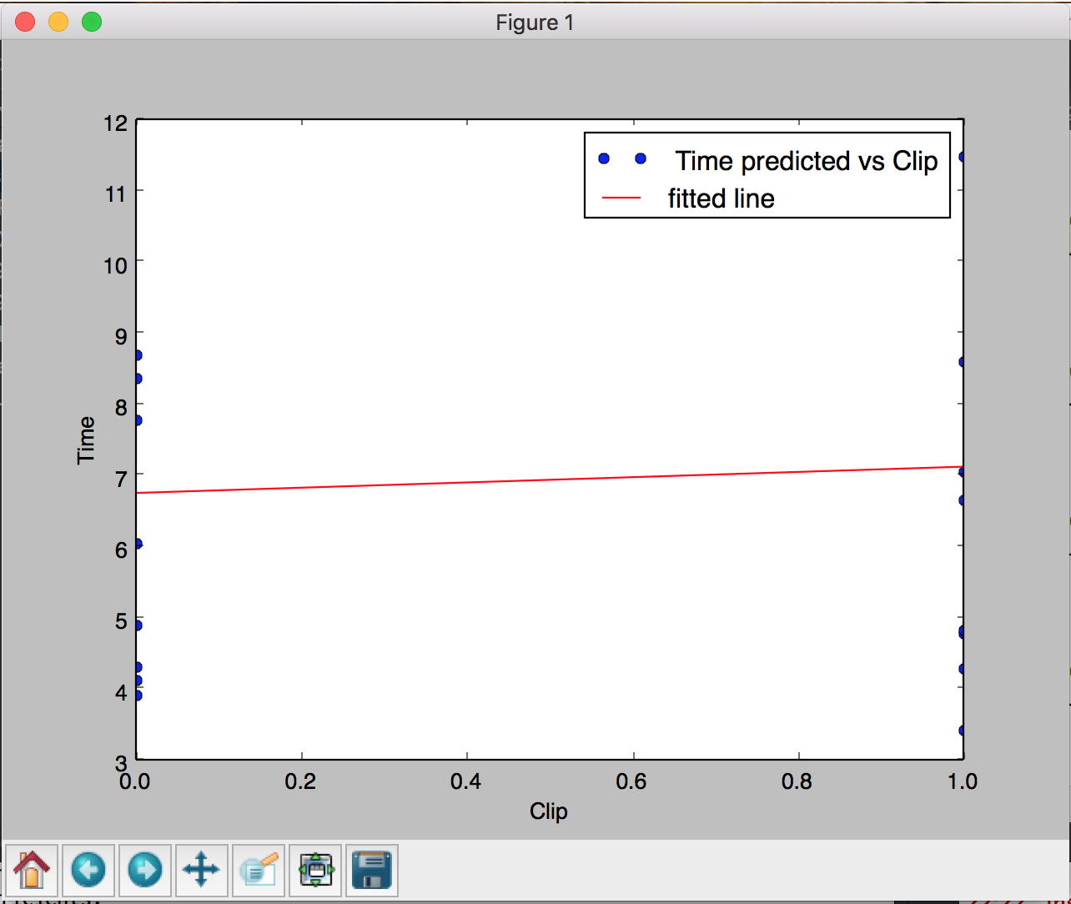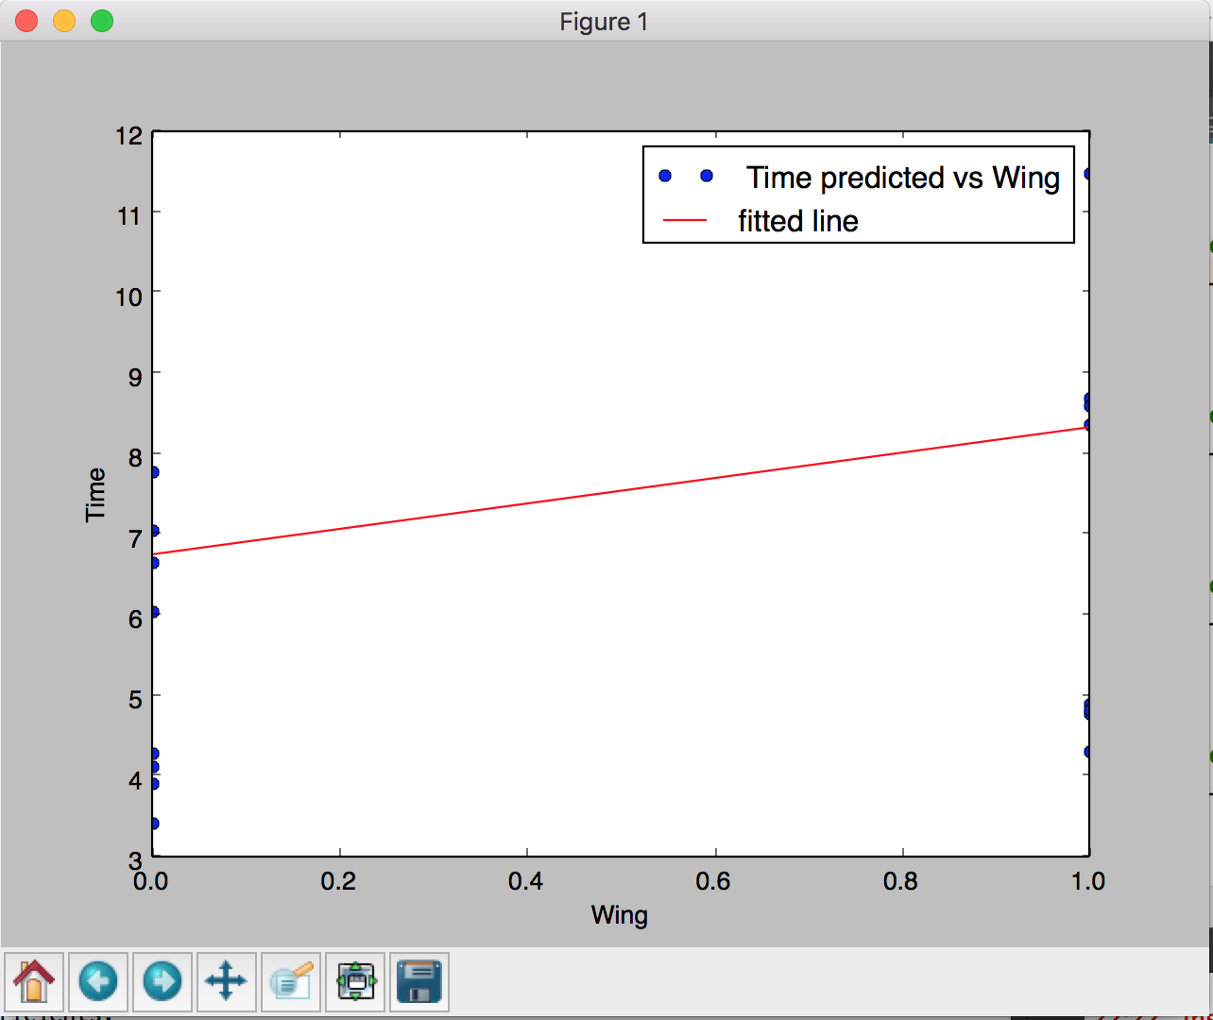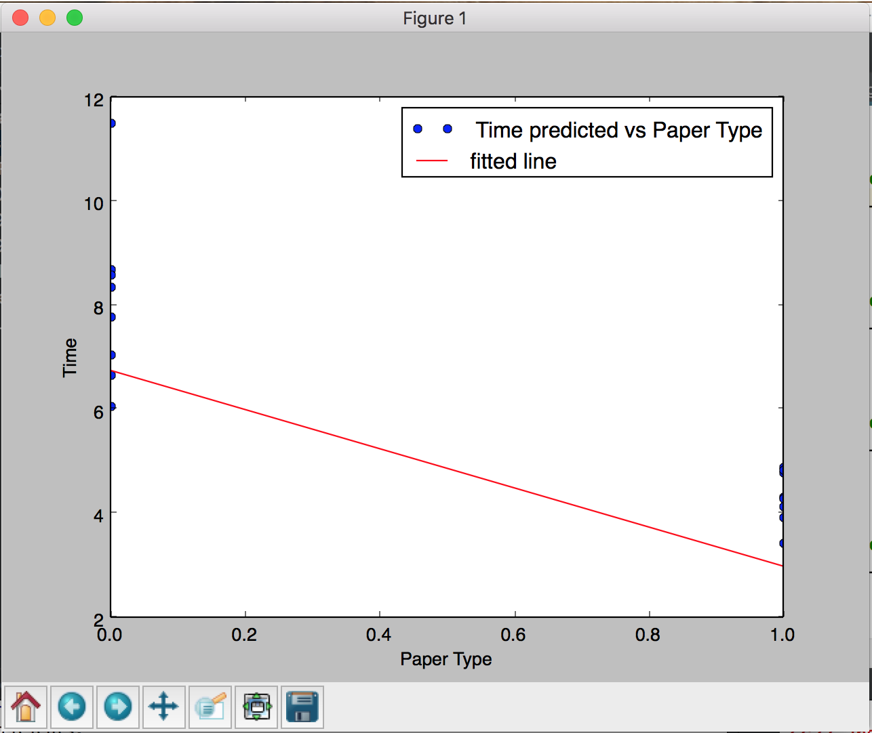

• Add to the data set the “Flight time predicted” and the “Residuals” (as seen in class, MCS_9100_ResidualAnalysisFromLinearRegression.pdf, slide 15)

• Analysis of Residuals as seen in class

◦R2

◦Plot of Residuals vs predicted.

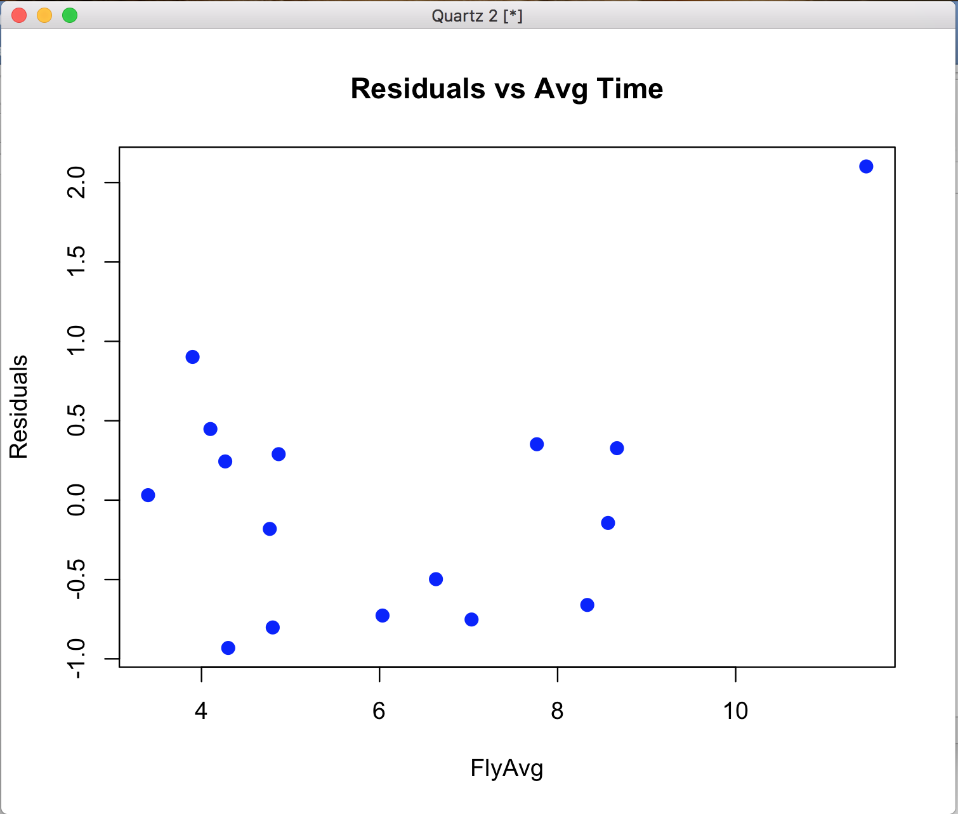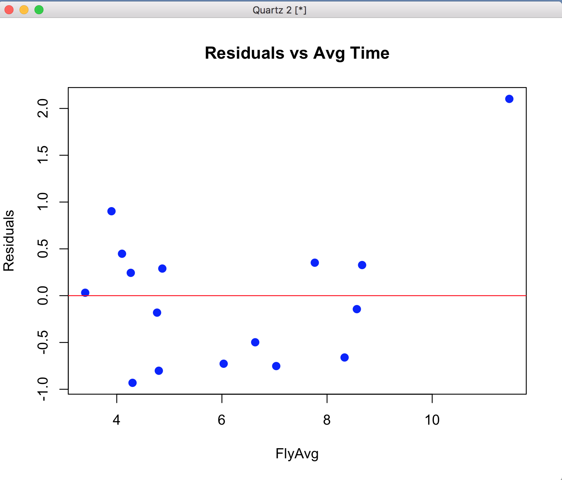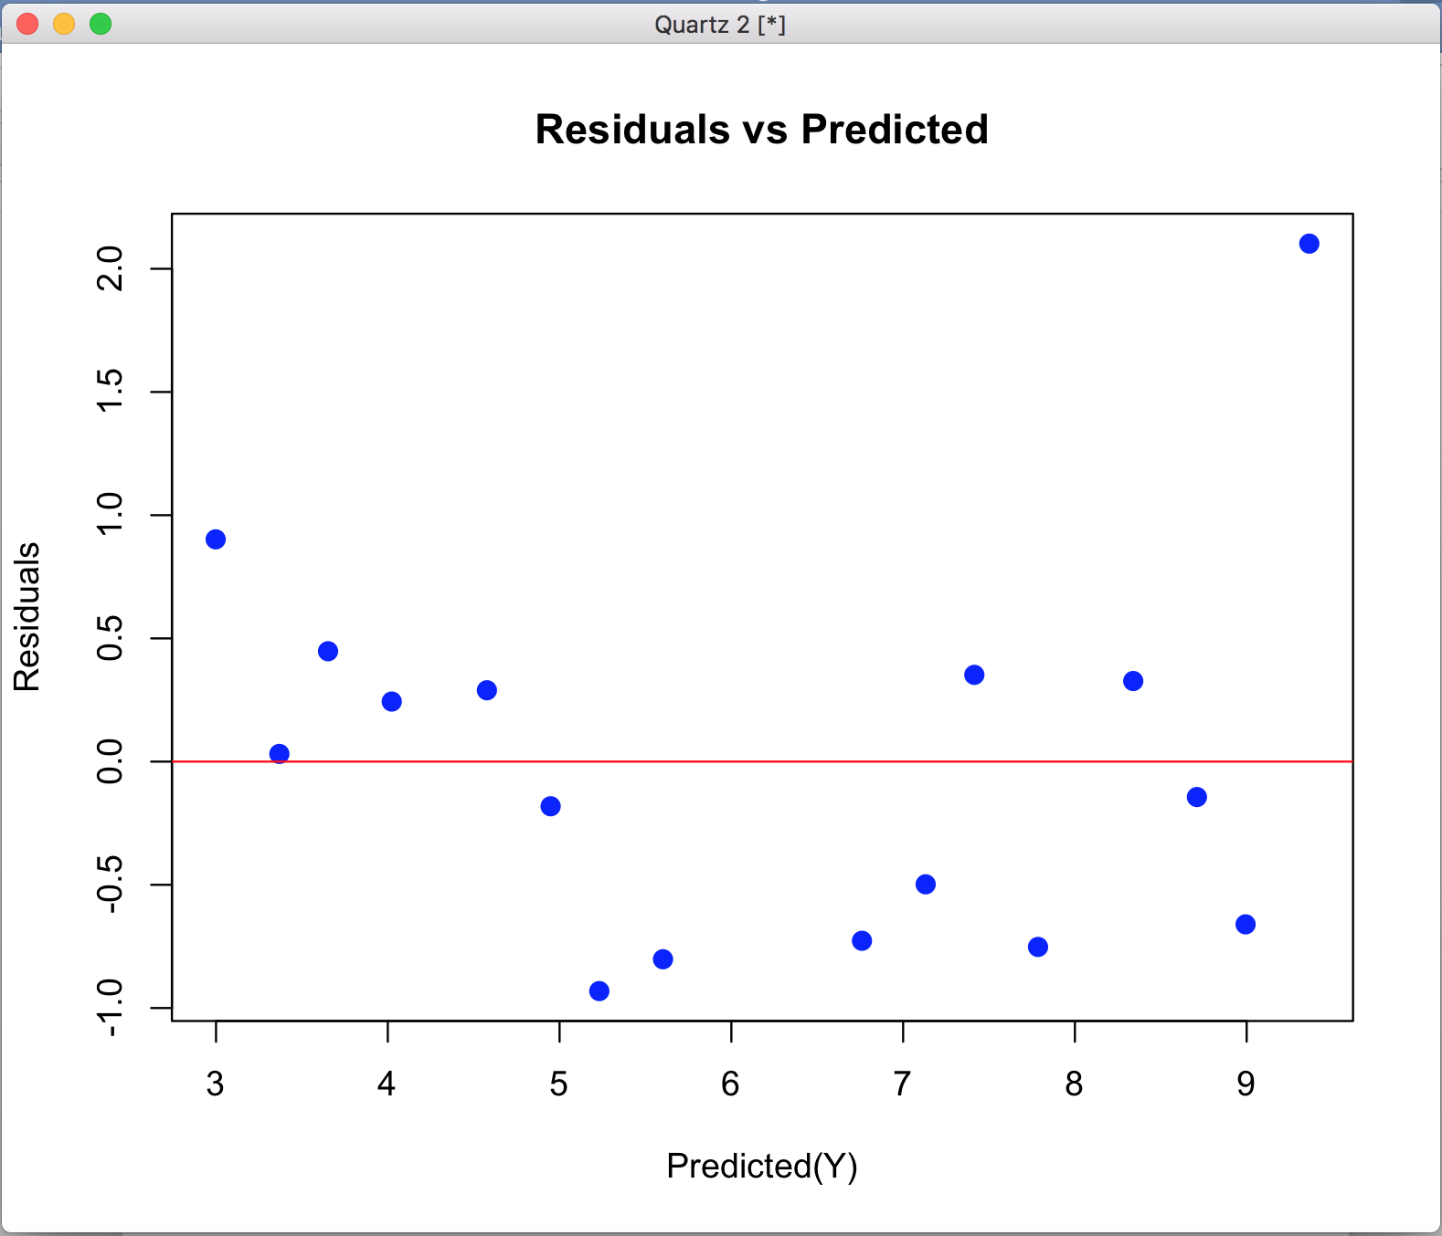

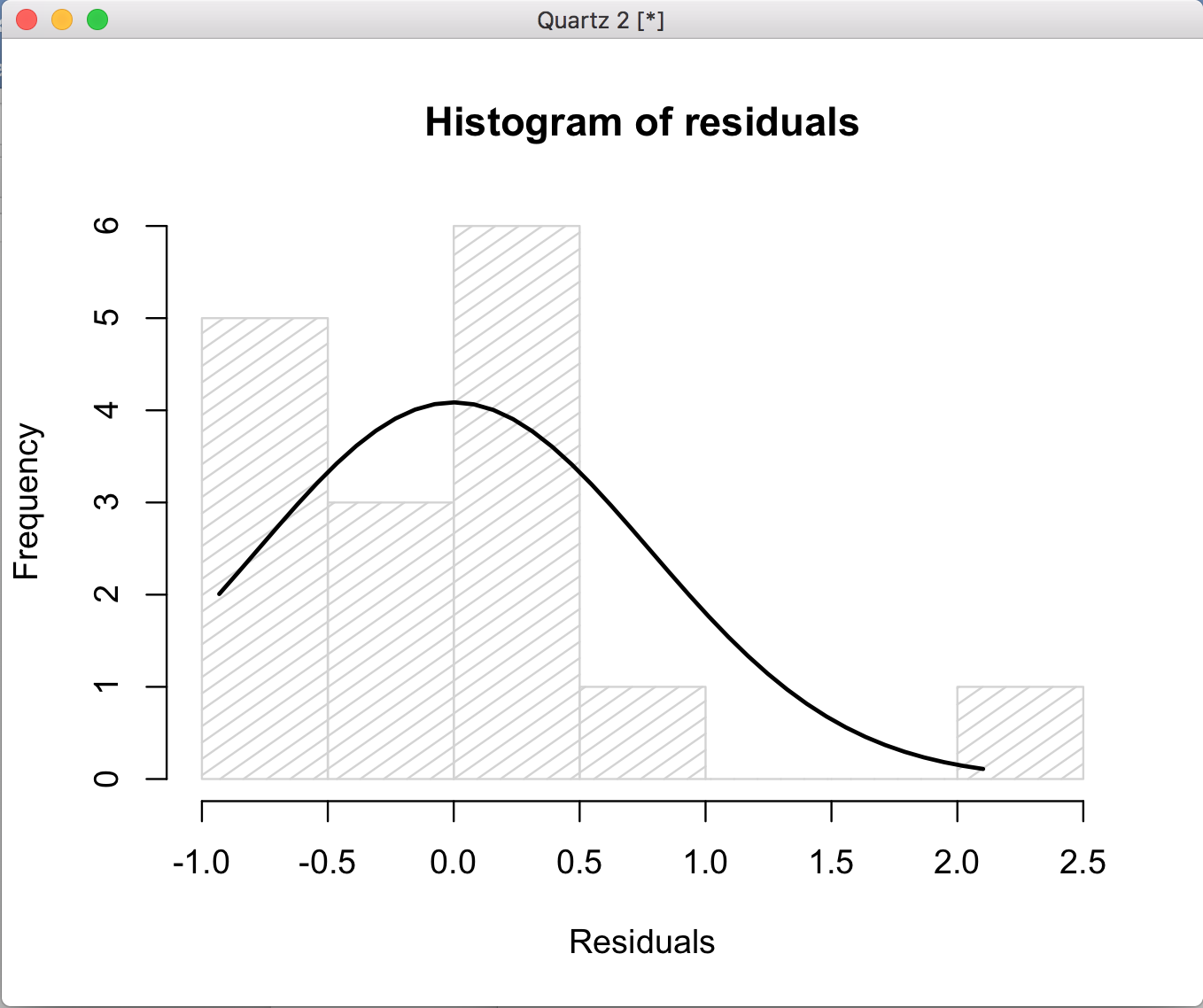

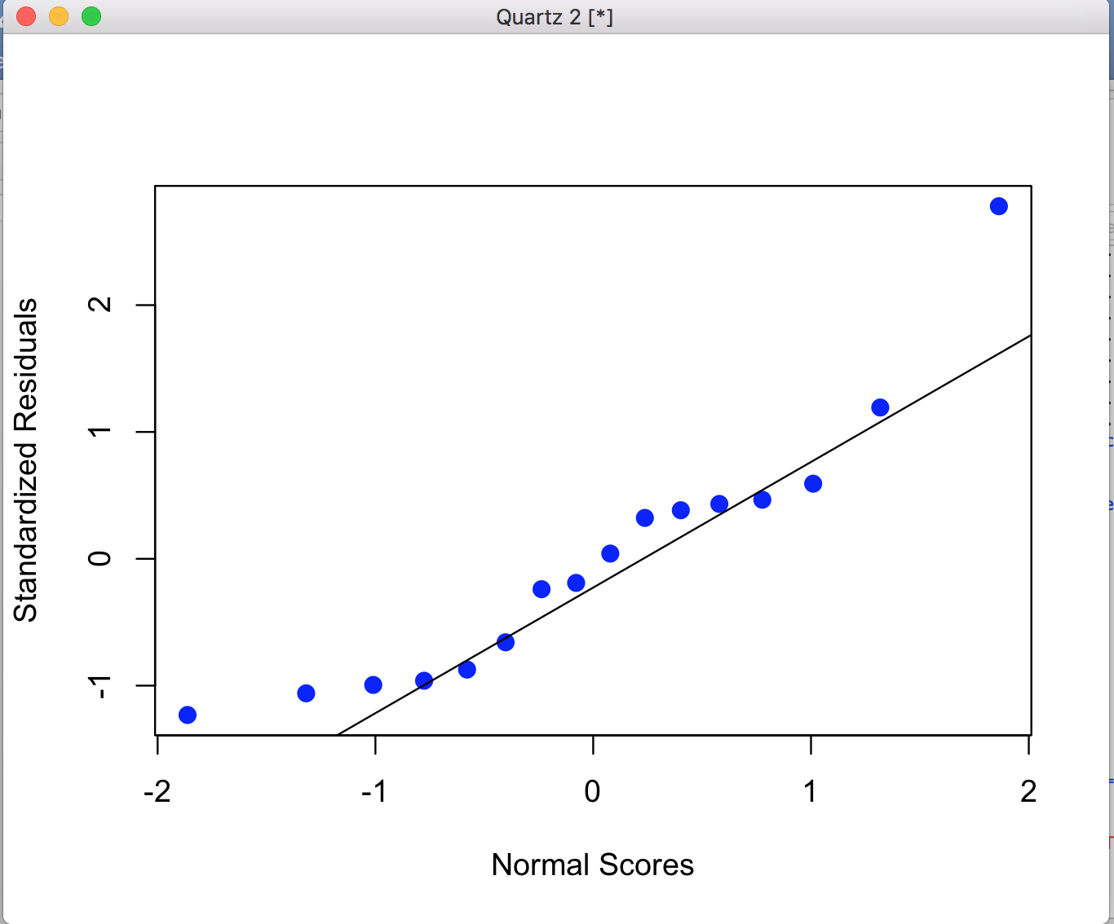

Explanation of the results of analysis of residuals, and normality of data

What we can say is that our model nearly matches the data, so it’s very close to 1 (the coefficient of termination R2) which means that is not perfect, but is actually a good model.

The normality of the data tends to 0 because that’s where the actually points (data), trend to be in.

Our residuals (errors) are minimal in our sample, maybe there are 2 or 3 exceptions, but the actual standard is nearly close to 0. So it’s good in this case.